ADMC International
618 E South St #500 Orlando, FL 32801
(407) 896-6378
info@admc-usa.com
www.admc-usa.com
QUALITY REAL ESTATE DEVELOPMENT SERVICE

ADMC International aims to raise the bar on the Real Estate Development industry in Central Florida by bringing in its years of expertise operating in the construction and development industry in Europe and the Middle East while providing a classical modern design.
An ADMC International Agent is ready to make a full-time commitment to help you capitalize on current market opportunities and assist you in making an informed decision. To ensure you make the right choice for the long term, an ADMC International Agent offers extensive knowledge in:
• Neighborhoods, schools and market conditions
• Mortgage specialists who can assist you with your financing options
• Property manager who can tend to your needs as one of our valued tenants.
What makes ADMC standout from the rest is the ability to carefully design your ideal place, build it and deliver to you according to your ideas, thanks to our experience in the construction industry. Your satisfaction and happiness is our success here in ADMC International LLC.
We thank you for choosing ADMC for all your home needs

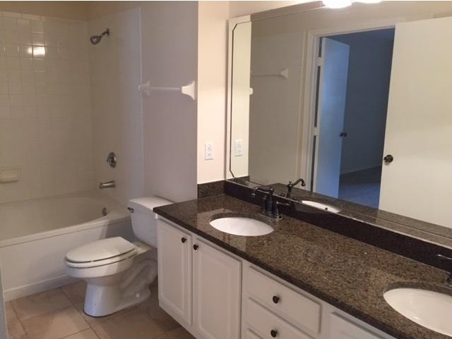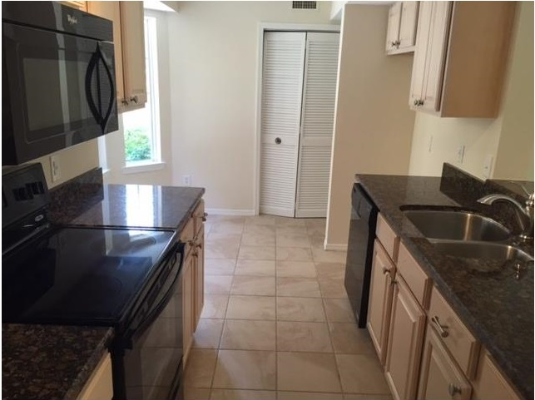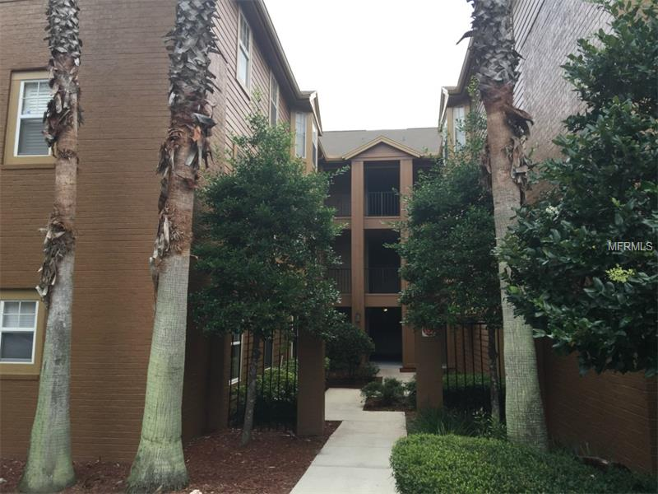
Description
This charming 2 bedroom 2 bath condo located on the ground floor is truly a must see! From the moment you arrive at the gated community you will feel a sense of arrival! As you make your way through you will immediately be greeted by the community social center featuring a pool, gathering room, fitness center and so much more! As you continue through the community you will see the well maintained exterior buildings, mature landscaping, green areas and more! As you arrive at the condo you will see this is a corner unit, ground floor and has a private entrance. The unit has been freshly painted and moderately upgraded. This unit also features a private screened in patio.

Appliances Included
- Dishwasher
- Washer/Dryer
- Disposal
- Refrigerator
- Microwave
Utilities
- Water Included
- Public Sewer
- Public utilities
- Progress Energy
Property Information
- County: Seminole
- Subdivision: Residences at Sabal Point
- 2 Bedrooms
- 2 baths
- Total Sqft. 1,365
- Cooling: Central
- Floor: 1
- Pets: Yes
- Style: Condo
- Screened in Patio
- Private 1 car garage
- Flooring: Ceramic tile/ Carpet

